Carla Valdez
Humanities 2300
Suzanne Jacobs
Spring 2013
World Religions: Sikhism, Christianity and Islam
Sikhism is an Eastern religion that originated in Indian, founded in the Punjab region that emerged from conflicts between the Hindu and Muslim religions. The main beliefs of this religion are monotheism, there is only one God but different religions call it different names, there is no right or wrong religion, and we are all equal human beings. It is the fifth largest religion of the world with approximately 23 million Sikhs worldwide. Sikhism was founded by Guru Nana, who then had nine other successive gurus. The last Guru was Gobind Singh, whose biggest accomplishment was completing the Adi Granth and forming the Khalsa, a Sikh army in charge of protecting the religion.
To be a Sikh, you have to have faith in the ten Gurus, faith in the Guru Granth Sahib, faith in one God, and faith in Amrit or Sikh “baptism”. Sikhs call God Waheguru/Akal Purukh which means greatest teacher, timeless being. The ultimate goal of a Sikh is to reunite their souls with God and that way find happiness and immortality. As a Sikh you must always honor God, seek God through knowledge, focus on God, fill yourself with the power of God and unite with God.
The most important aspect of a Sikh service is the Holy Scripture or Adi Granth. Most of the service consists of people singing it because when the Adi Granth was being written it was meant to be sung or chanted. Everyone in the service sits on the floor at the same lever to emphasize their teaching on equality. Rich or poor you are going to be seated at the same level as your neighbor and everyone else in the service.
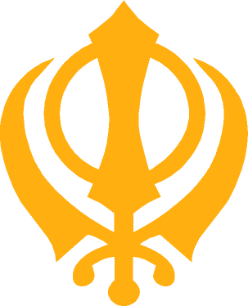
In the Sikh temple the space is really empty, the focus point is in the center, front which is really colorful and beautiful but unlike other temples from other religions they do not have any images or sculptures. They see God as a more spiritual figure therefore they do not represent him as something physical as other religions do. They also only worship one God, not any abstracts forms of it like Christians do with saints. They go to the temple to focus on God and the Holy Scripture not to look at other images or sculptures.
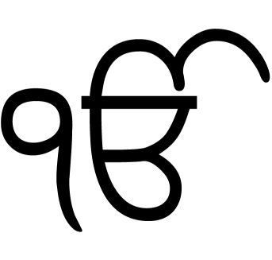

In the temple the symbol of the Khanda was represented a few times. I even saw some people wearing a necklace with this symbol. Just as the cross is to the Christians and the star of David is to the Jews, the Khanda is a representative symbol to the Sikhs. The sword that appears at the front of the symbol represents Divine Knowledge.The circle around the Khanda is the Chakar. The Chakar symbolizes the perfection of God who is eternal. I also saw the symbol called Ik Onkar which symbolizes the phrase “there is only one God”.
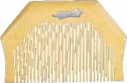
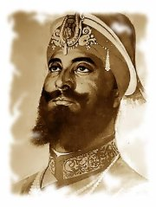

When Guru Gobing formed the Khalsa he gave them five items that they should always wear. Many men in the service were wearing those five items. These items are a sword (Kirpan) to protect Sikhism and the weak. Uncut hair (Kesh), usually covered by a turban. A steel bracelet (Kara), symbolizing strength and integrity. A small wooden comb (Kangha), symbolizing cleanliness and order. And special shorts (Kachhera) symbolizing self-control and chastity.
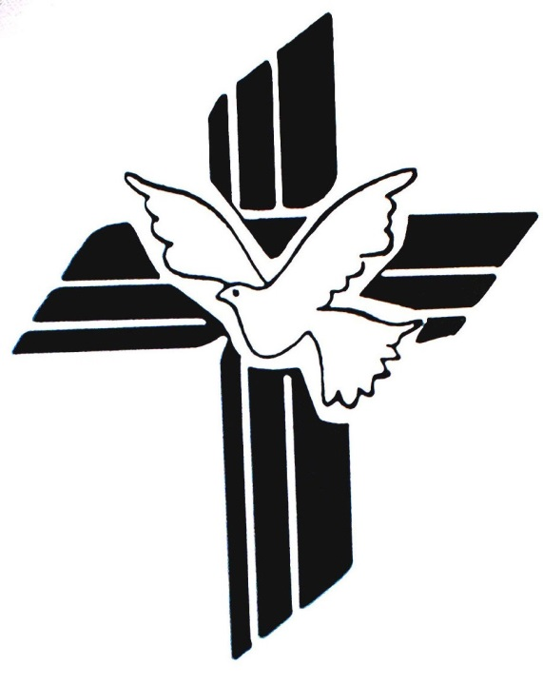

Christianity is the largest religion in the world with about 2.1 billion members worldwide. This religion is based on the teachings of Jesus Christ, who Christians believe was God’s son, and also the Bible is the foundation of this religion. The Bible consists of the Old and the New Testament. Christians believe God is the Creator and ultimate authority in heaven and Earth and that at the end of our days we will be judged by Him and have the opportunity to live eternally with God. Another belief of Christianity is the Trinity, God is manifested in three forms or persons, God the Father, Jesus the Son, and the Holy Spirit. A good Christian must follow the ten commandments of God and go through the sacraments during their lifetime: Baptist, Confirmation, Communion, and Matrimony or Holy Orders.
I attended the Catholic service at the Cathedral of the Madeleine. The Trinity in which Christians believe in was physically present in the building, especially in the paintings. In the front wall, there was a big painting of Jesus being crucified. Behind him, there was an image of God, kind of hugging him. I think this represents Jesus as human, dying and suffering, and as divine, God’s son. At the bottom the phrase “Jesus died for all of us” was written. At the very bottom of the cross, the Holy Spirit was represented with a pigeon. At the beginning of the service the priest entered the Cathedral with other people; one of them was carrying a big cross, which is a representative symbol for Catholics.
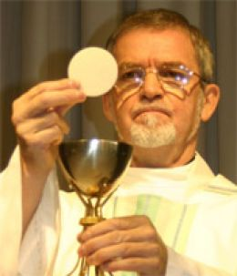
As I have mentioned before, the Bible is the foundation of Christianity and it is the holiest and most important scripture. At the service when they were about to read a passage from the Bible, they pointed out its importance by carrying it high to the podium and followed by other people carrying basins of burning incense. After the passage was read, the priest explained and interpreted the meaning and what teaching we should take from it. Incense also seemed to be a very important and representative thing in the Catholic Church since it was present many times during the mass.
Towards the end of the service, Eucharist happens. The priest begins by blessing the wafer and the wine, and then giving it to the people who choose to participate in this sacrament. The wafer represents the body of Jesus and the wine, his blood. Christians believe that when the priest blessed these they are somewhat converted to the body and the blood of Jesus Christ, although we don’t see it physically. After taking a piece of wafer and a sip of wine everyone goes to their seats and gets on their needs to have a talk to God and meditate. This sacrament is given to Catholics through communion, after they have done their communion they can take ‘the body and blood’ of Christ.

Islam is the second largest religion of the world with about 1.5 to 1.8 billion members around the world. It was founded in the Middle East and it has become the official religion of the Arabs as well as the fastest growing religion with a 6 percent annual increase. Muslims believe that there is only one God, and that is Allah. He is the creator of everything, and eternal as well as judge of our actions. They also believe in Prophets, messengers of God, angels, the Day of Judgment and living an obedient life by being good to others. Islam is also based on their holiest scripture, the Qur’an, which they see as a revelation from God and his teachings.
At the Mosque I attended women and men were separated to avoid distraction and be able to focus. Women were upstairs and men were downstairs Islam teaches that when you are about to talk and pray to God you must be in a pure state, meaning being clean. When you enter a mosque, there is some wash stations where you must clean yourself up before praying and also you must remove your shoes. Women must be all covered up from head to toe in sign of respect by wearing a veil, really long skirts or pants, and long sleeve shirts.
Mosque or masjid, translated into Arabic, means place of prostration. When coming in to the mosque Muslims prostrate themselves on the floor to pray to God, this helps them to focus more and forget about their surroundings at that moment. Prostrating also is an expression of submission and humility towards God. One of the teachings of Islam is that Prayer or Salat is an obligation and it must be done five times a day. When Muslims pray, they again prostrate themselves on the floor facing in the direction of Mecca, their holy city. The temple I went to was built so it would already be facing the city of Mecca. At the beginning of the service the Imam, the person who leads the Mosque, pronounces the phrase “Allahu Akbar”, which means God is the greatest to prepare for the prayer.
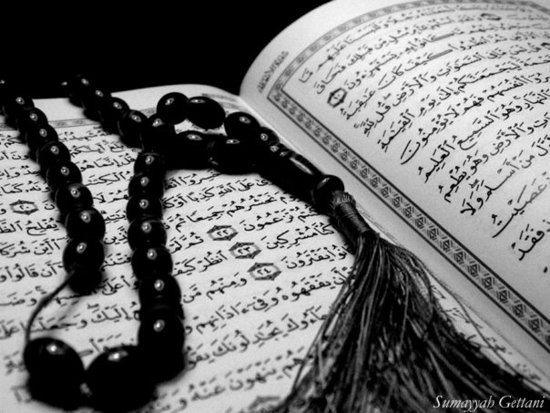
Since the Qur’an is originally in Arabic, Muslims believe it should not be changed, nothing should be added to or removed from it, and it should not be translated because it loses its exact meaning. Most of the service that I attended to was in Arabic, the chapters read from the Qur’an were recited in Arabic as well and then the Imam would explain them in English. When the Imam was giving the sermon he talked about angels, which is one of the things that Muslims believe in. They see angels as messengers of God, who deliver revelations. Angel Gabriel delivered Muhammad’s first revelation. They also, just as Christian, believe in Satan therefore there is good and evil in this world.
Christianity and Islam, which are both western religions, are more similar and there are more difference between them and Sikhism but they all show some similarities and differences. Sikhism and Islam are both strictly monotheistic religions while Christianity believes in the Trinity, god’s manifestation in three forms. Sikhism and Islam reject any statues or images of any form since they considered that idolatry. They must only worship God and since God is unique, nothing can be associated with Him. On the other hand, one of Christianity’s foundations lays on the trinity. They believe in one God, who is manifested in three forms, the Father, the Song and the Holy Spirit.
All three religions have their own holy text, Sikhism’s is Adi Granth, Islam’s is the Qur’an and Christianity’s is the Bible. All three scriptures contain the teachings of God and His word. All three religions had prophets or in the case of Sikhism, Gurus, who members of each religions see as teachers and people to spread the word of God. While Christians sees Jesus as God’s son, Muslims see him as a prophet of God.
Sikhs believe in a constant cycle of reincarnation until enlightenment is reached. Christians and Muslims believe in the resurrection of the soul and that God is Judge and he will judge you according to your actions during your life time at the end of your days. If you were a good person, you will go to heaven and live eternally by the side of God, and if you were a bad person you will go to hell. Both, Christians and Muslims also believe in supernatural beings like angels and the devil. Angels are seen as messengers of God but can also have different duties, and the devil, Iblis in Islam, tempts us to do things that go against God’s commandments.
Active Christians and Muslims must do certain things during their lifetime. While Christians call them sacraments, Muslims call them the five pillars of Islam. The Christian sacraments are Baptist, Confirmation, Communion, and Matrimony or Holy Orders. The five pillars of Islam are Shahaba (faith), Salat (prayer), Sawm (fasting), Zakat (charity) and Hajj (pilgrimage to the city of Mecca). In the case of Sikhism, Sikhs have the five items that they must always have with them, Kirpan (sword), Kesh (uncut hair), Kara (steel bracelet), Kangha (wooden comb) and Kachhera (special shorts).

